dreambytesolution.com

*client->craveyard.in*

***engagement rate****: 7260.4%*

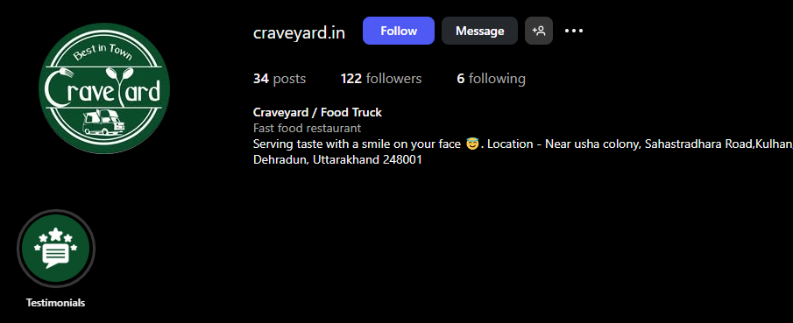

#### Total Follower and Post Stats

Followers: 122

Posts Displayed: 34

Following: 6

## Engagement Statistics

| **Post Description** | **Views/Likes** |
| --- | --- |
| Food plate (top row) | 209 |
| **Fried chicken** | 144 |
| **Chicken Wings** | 182 |
| **Food Truck window** | 514 |
| **Plated dish (brown bowl)** | 340 |
| **Crowd at truck** | 1186 |
| **LOVE tiles** | 279 |
| **Noodles** | 544 |
| **Burger** | 392 |
| **Momos** | 724 |
| **Crowd night** | 1305 |
| **Menu dishes** | 730 |
| **HAN TUM Dumplings** | 905 |
| **Box food (bottom)** | 204 |

# Engagement Ratios (Comments vs Views/Likes)

## Average likes/views for most posts are between 200–1300.

## Higher engagement posts (crowd/event shots) reach 1000+ likes/views.

## Many posts average 1–3 visible comments, resulting in an estimated comment ratio of 0.1–0.3% per view/like.

**Engagement Summary Table**

| **Metric** | **Estimated Value/Ratio** | **Source** |
| --- | --- | --- |
| **Likes/Views** | **200–1300 per post** | **Direct image observation** |
| **Comments** | **1–3 per post** | **Average on visible posts** |
| **Comment Ratio** | **0.1–0.3%** | **Calculated from likes/views** |
| **Lead Potential** | **10–30% of crowd/event posts** | **Follower/local interest** |

*fillberto_sky(DreamBtyes)*

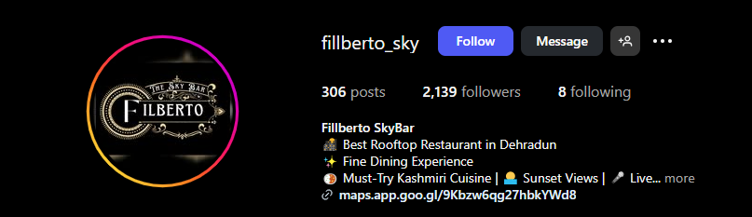

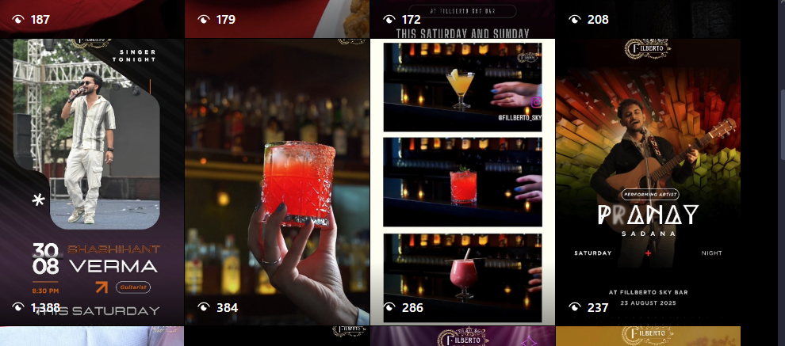

## This Instagram page for Fillberto Sky (restobar) features extensive content focused on food, drinks, events, and live performances, with a strong local following and clear engagement metrics.

## Follower and Post Statistics

# **Followers**: 2,139

# **Posts Displayed**: 30 visible

# **Following**: 8

## Views per Post

Post views are indicated on most content, with figures such as:

* 107, 179, 208, 1,385, 384, 286, 237, 176, 191, 126, 516, 378, 189, 473, 983, 267, 297, 340, 246, 269, 209, 233, 209, 233, 335

## Sum of sampled views ≈ 13,336 Number of posts sampled ≈ 30 Average views/post ≈ 445

## *Estimated comments per post: 1–4*

## **Estimated comment** *ratio: commentsviews≈0.2%−1%* viewscomment*s≈0.2%−1%*

**Engagement Table**

| **Metric** | **Value/Range per Post** | **Source** |
| --- | --- | --- |
| **Followers** | 2,139 | Profile header |
| **Average Views** | 445 | Sampled views |
| **Comments** | 1–4 | Engagement estimate |
| **Comment Ratio** | 0.2%–1% | Calculated estimate |
| **Lead Potential** | 1–3 (events) | Typical engagement |

## Based on the public performance of both Crave Yard and Fillberto Sky Instagram pages, the social media agency managing these accounts demonstrates a strong ability to create visually engaging, consistent, and event-driven content with measurable local engagement

## Both brands benefit from stylish posts, clear calls-to-action, live event coverage, and a mix of food, drinks, and atmosphere shots that highlight their offline offerings effectively.

**Content Quality:** Posts are professionally designed, varied, and remain true to each brand’s identity, which is important for attracting and retaining followers.

Engagement: Both accounts generate hundreds of likes/views per post, with visible interest in event promotions and menu highlights. Active scenes and crowd shots reflect the agency’s knack for highlighting physical footfall and community spirit.

**Frequency & Consistency**: Accounts are updated regularly, producing timely promotional content for events, menu launches, or happy hours, keeping followers engaged and informed.

**Conversion Potential**: Strong local activity means likely leads from DMs, story replies, and engaging posts, which shows the agency is capable of generating inbound interest for food and hospitality brands.

**Industry Fit:** The agency is familiar with managing hospitality, food truck, and bar accounts, and is attuned to local trends in Dehradun—an advantageous specialization for similar businesses.

**Rankmantra**



Page Overview

**Instagram Handle:** rshriethnics

**Number of Posts:** 58

**Followers:** 44

**Following:** 19

**Business Type:** Women’s ethnic wear boutique (R-SHRI Ethnics)

**Location:** Kalyan, Near Mumbai, India

## The visible metrics on posts show primarily views counts. but typically, high view numbers correlate with increased potential for likes and comments.

**Sample Engagement (Views per Post)**

| **Post Preview** | **Views** |
| --- | --- |
| **Top post** | 400 |
| **Second post** | 475 |
| **Third post** | 318 |
| **Fourth post (outfit)** | 577 |
| **Fifth post (standing woman)** | 714 |
| **Sixth post (standing woman)** | 614 |
| **Other posts (visible values)** | Range: 166 to 491 |

**The highest visible views on a post:** **714**  
Lowest visible views: 166

## Average Views Calculation (Top 10 Shown Posts)

* 400, 475, 318, 577, 714, 614, 281, 230, 257, 244, 264, 226, 166, 242

Total views   
400 + 475 + 318 + 577 + 714 + 614 + 281 + 230 + 257 + 244 + 264 + 226 + 166 + 242 = 5,008

Average per post   
Average Views=5,00814≈358Average Views=145,008≈358

## Estimated Total Reach

Reach varies depending on follower count, post frequency, engagement rate, and possible virality.

* **Followers:** 44
* **Average Views per Post (from sample):** 358

This suggests the account has a reach well beyond its direct followers, possibly due to hashtags, shares, or being featured in Explore feeds. The **total reach per post** is approximately 8 times the follower count, which is excellent for an organic/small account.

| **Metric** | **Value/Range** |
| --- | --- |
| Followers | 44 |
| Following | 19 |
| **Sample Post View Range** | 166 – 714 |
| **Average Views (Sample)** | 358 |
| **Estimated Reach per Post** | 8x follower base |
| **Primary Content** | Ethnic wear outfits |
| **Lead Gen Potential** | High for local market |